**Report 1 Complete**

**Problem Statement:** Problems constantly arise in everyone’s lives that make them unable to do the everyday tasks needed to survive. Throughout the recent years, technological advancements have made it possible for these tasks to get completed by an outside party. The grocery delivery service applications have been very beneficial to those who are unable to go to the store due to injury or sickness and also to those who really don’t like going to the store. As a customer, I prefer to get specific items when going to the store and like certain brands more than I do others. What the current grocery delivery services lack are the ability to specifically select a replacement product if the wanted product is not in stock. Most of the time, if a product is not in stock, the delivery person will substitute for another brand or not buy the item at all. This can be frustrating as the consumer because the one product they did not have may have been something that you needed right away. Even though the delivery person made the substitution, they probably selected the nearest item that looked similar when you could have made the selection yourself on what other brand you wanted. This issue could be easily avoided if the applications would allow for the buyer to see the number of items that are in stock and be able to select a back-up item if the item that they originally wanted is out of stock or low in stock. That way if the delivery person gets to the store and the selected item is not in stock, they know automatically what to substitute it with instead of picking a random brand. The final issue that doesn’t occur as often is delivering to the wrong address. With COVID, a lot of delivery services have been dropping the items on the porch without directly having contact with the person they are delivering to. The issue with this is they do not 100 percent know that the items are being delivered to the right house.

**Glossary of Terms**

* # In Stock: This will display the number in stock of each item.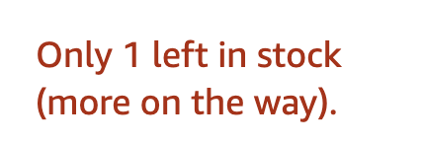
* Flat-Rate: Every consumer will get charged the same flat-rate delivery fee no matter how big or small the order is.
* Returns: Returning an item will only be accepted if the item is received damaged or the wrong item was delivered.
* Concurrent User: the process of having several users on the site at one time. Once the site goes live across the nation, it will be extremely important that the site can withstand an unlimited amount of users at one time without the possibility of a website overload or shutdown.
* Special Limitations: these would most likely be found in the terms and conditions of the application and identify things such as specific delivery cut-off times and price changes with on-sale items.
* Authentication: require all users to provide a valid ID and also a picture of the front of the residence where the items are being delivered to always ensure that the items arrive at the proper address.

**Functional Requirements**

|  |  |  |
| --- | --- | --- |
| **Requirement** | **Priority Weight** | **Description** |
| Stock Check | High | Allow users to see the number of items that a store has in stock. |
| Item Substitution | High | Allow users to select a replacement item if the desired item is out of stock or low in stock. |
| Proper Delivery | Low | Ensure that the items arrive on time, not damaged, and to the correct address. |

**Nonfunctional Requirements**

|  |  |  |
| --- | --- | --- |
| **Requirement** | **Priority Weight** | **Description** |
| Reliability | High | Ensuring that the application can sustain a high volume of users at one time. |
| Usability | High | Creating a user-friendly application that anyone over the age of 16 will be able to use. |
| Delivery Prompt | High | Customer will be prompted to sign-off on the app once the delivery person has arrived. |

**User Interface Requirements**



|  |  |  |
| --- | --- | --- |
| **Requirement** | **Priority Weight** | **Description** |
| Items in Stock | High | Actively display the number of an item in stock. |
| Item Substitution | High | Prompt a list of similar items for substitution |
| Address Verification | Low | Take a picture of your residence to ensure of proper delivery. |

Similar Products

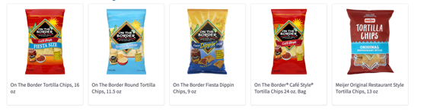

**Report 1 Part 2**

**Stakeholders:**

* Blake Jagielski (Myself, Project Creator)
* Grocery Stores
  + Meijer
  + Kroger
  + Walmart
  + Etc.
* Grocery Store Customers
* Investors
* Management Employees
* Financial Employees
* Programming Employees

**Actors & Goals:**

* Customers
  + Will use the application to purchase grocery products from their favorite stores.
  + The goal is for the customer to be able to use the application with ease and without the difficulties and errors found in other delivery applications.
* Programming Employees
  + Will be in charge of any debugging or updates that need to be applied to the application.
  + The goal is for the programming employees to complete the tasks and projects given to them in an efficient and timely manner.
* Computer or Cellular Device
  + These devices can be used to navigate the grocery delivery application and will create a user-friendly experience for all customers.
* Management Employees
  + Control business operations and communicate with store locations about brand deals and product specifications.
* Delivery Drivers
  + Receive delivery notifications through the application and respond by going to the selected store(s) and picking up the desired items.

**System Requirements Casual Description:**

* Stock Check
  + Customers will be able to see the number in stock of the items that they select to purchase. For example, if an item is out of stock, the customer would be prompted to select a similar item.
* Item Substitution
  + If an item is out of stock of limited in stock, the customer will be prompted to select a similar item. For example, if an item shows that there are only 2 left in stock, the user will see a list of similar items displayed that they will be able to choose from as a back-up item in case the item is out of stock once the delivery driver gets to the store.
* Proper Delivery
  + Customers will be prompted to upload a photo of the front of their residence where the delivery is expected. If their residence is an apartment, they should upload a photo of the apartment door with the number clearly displayed.

**Use Case Diagram:**

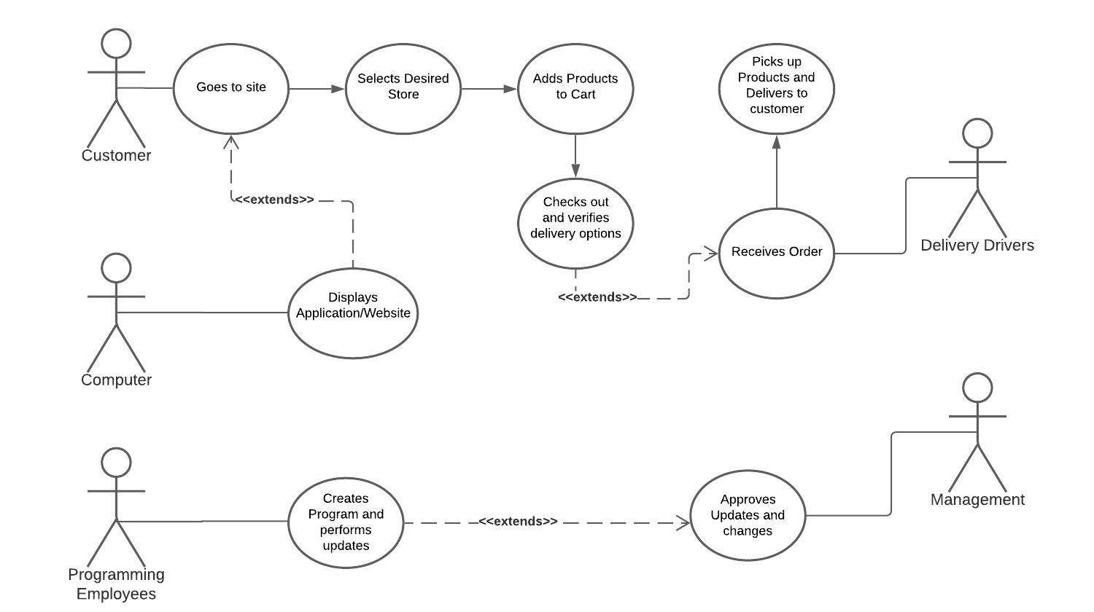

**Traceability Matrix:**

|  |  |  |
| --- | --- | --- |
| **Requirement** | **Priority Weight** | **Description** |
| Items Selected | High | User will be able to select items from the store’s website with ease. |
| Checkout Process | High | Customers will have a user-friendly experience throughout the ordering process and paying for their items. |
| Proper Delivery | Low | Ensure that the items arrive on time, not damaged, and to the correct address. |

**Fully-Dressed Description:**

* Customer Placing an Order
  + Customer will visit the website on his/her mobile device or computer.
  + Once on the site, user will select the ‘Stores’ Tab in the navigation bar.
  + The user will then select their preferred store to shop with.
  + The user will then be redirected to that stores page.
  + The user can then select products by categories or use the search bar.
  + Once the user finds a desired product, they will add the product to their cart.
  + Once all of the items have been added to the cart, they will click on the shopping cart icon in the top right-hand corner of the page.
  + The user will click the ‘Checkout’ Button.
  + This will redirect the user to the checkout page where they will enter address and payment information.
  + Once completed, the user will click ‘Submit Order’.
  + Once submitted, the nearest delivery driver will be notified.
  + The delivery driver will go to the store and pick up the requested items.
  + Once finished, the driver will deliver the items to the customers residence and the order is complete.

**System Sequence Diagrams:**

* Customer placing an order through the website

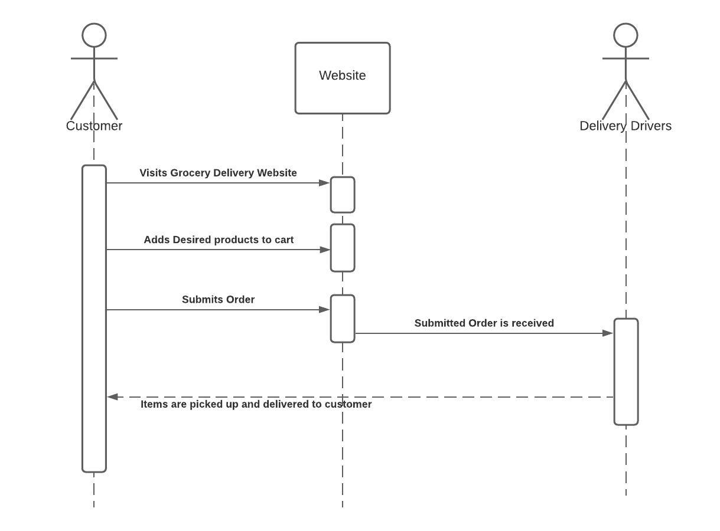

**Preliminary Design:**









**User Effort Estimation:**

* Customer wants to buy a specific product from a specific store
  + Customer enters the website
  + Clicks on the ‘Stores’ navigation tab
  + Clicks on the desired store they would like to shop
  + Customer can select a certain category or search for their grocery items.
  + Customer selects product
  + Customer adds product to cart
  + Customer clicks on the cart icon
  + Customer clicks on checkout
  + Customer enters payment information (unless saved payment information is available).
  + Customer clicks proceed with payment and delivery options
  + Customer will upload a photo of the front of their residence (unless one is pre-saved to your account.)
  + Transaction is complete
    - Total Mouse Clicks: 10-14 mouse clicks (Only 1 item purchased)
* Customer wants to contact us
  + Customer enters the website
  + Clicks on the ‘Contact Us’ navigation tab
  + Enters Name, Email, Subject, and their message to us.
  + Clicks send once complete
    - Total Mouse Clicks: 4-7 Mouse Clicks (Dependent on if the ‘Tab’ Key is used to go through contact form.)
* Customer wants to track their order
  + Customer enters the website
  + Clicks on the ‘My Account’ Icon in the top right corner of the page
  + Selects ‘Track an Order’
  + Selects which order(s) they would like to track
  + Result is displayed
    - Total Mouse Clicks: 4 Mouse Clicks (1 Single Order)

**Domain Model**

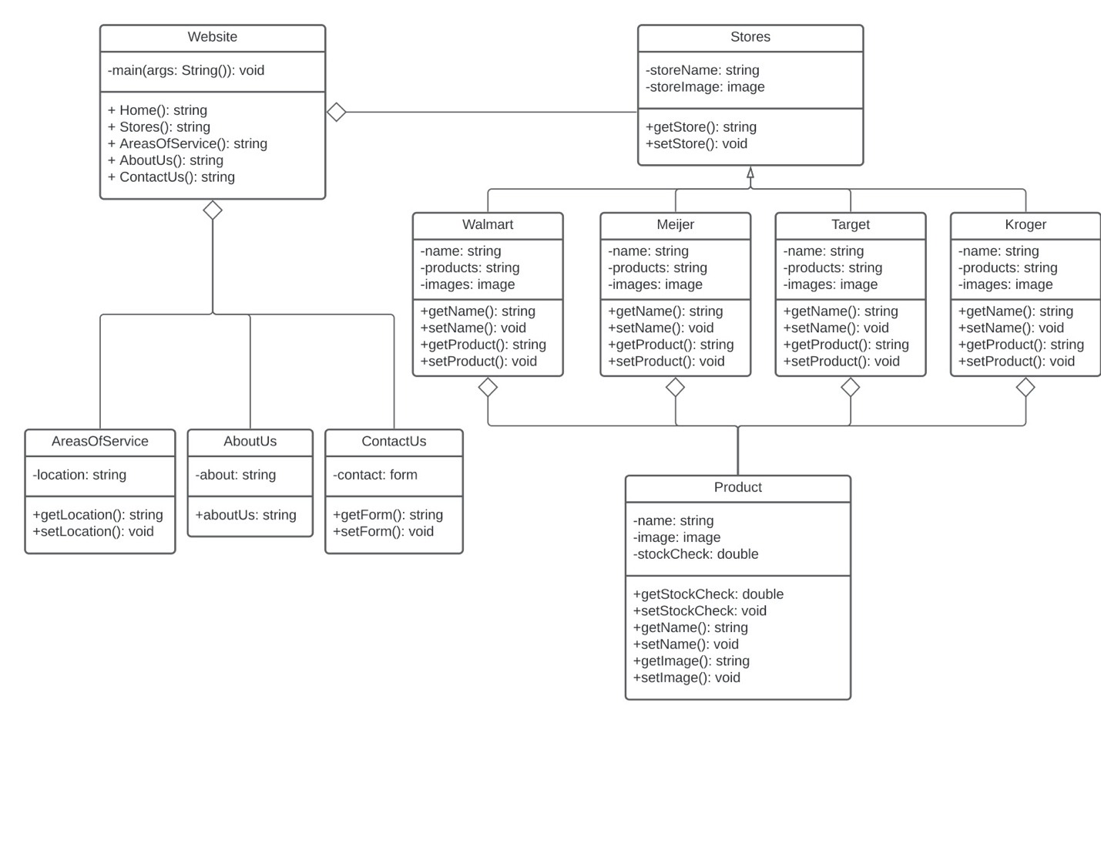For the purpose of this project, all 4 of the stores will have the same products displayed when the tab is clicked. A different store image will still be displayed, but the same products will be displayed across each store. The website is the main class in this program and when visited will automatically display the home page. The Stores, Areas of Service, About Us, and Contact Us pages are all separate classes. The products displayed on the store pages will consist of a product name, image, price, and quantity in stock.

**System Operation Contract**

Contract CO1: orderProduct

**Operation:** orderProduct()

**Cross References**: Use Cases: Add Product to Cart

**Preconditions:** Customer selects desired store

**Post Conditions**: -An order is created (instance creation).

-Product was associated with the store (Association Formed)

-Attributes of the product are now initialized

Contract CO2: deliverOrder

**Operation:** deliverOrder()

**Cross References**: Use Cases: Received Order, Pick up and Deliver Order

**Preconditions:** Customer adds desired products to cart & checks out

**Post Conditions**: -An order is received.

-Order is then processed and picked up by delivery driver.

-Products are delivered to customer.

**Project Size Estimation**

After evaluating the completed portions of Report 1, I have put together a breakdown of things that the project will include which will better determine the scope and size of the project

* There are no financial costs associated with this project since it is being completed for a class project.
* I am the only team member involved, so in terms of the project, the entire deliverables must be completed by me within the time period given for when the project is due.
* This project will produce a Grocery Delivery Service website which will contain several classes containing java, javascript, html, and css programming. I am estimating there to be 12-15 pages of source code once completed.
* As stated in the domain model, every page will have its own likeness except for the product page which will be displayed the same across all of the store pages.

**Plan of Work**

Upon completion of Report 1, I will continue with the programming of the website. Currently, I have the overall basic html layout for the webpages and plan to begin working on the in-depth java and javascript coding this week. I plan on starting report 2 this week as well having the first part completed by March 16th and the second by March 23rd.

Major Milestones:

* Report 2 completed by March 23rd
* Rough Program completed by March 31st
* Debug & Test throughout first 2 weeks of April
* Completed Program by end of third week of April

**References**

* Image References have yet to be determined
* Deitel, Harvey M. *Java: How to Program (Late Objects)*. Pearson Education Limited, 2015.
  + This is a reference to a textbook that I am currently using for another class, but I have been looking at some of the concepts from the book for help with the programming.
* Tilley, Scott & Rosenblatt Harry *Systems Analysis and Design, Eleventh Edition.* Cengage Learning, 2017
  + Course Textbook